**Production configuration steps**

Step1 configure scheduler in main class

For Video Link=https://youtu.be/zxM6ppSGeJY

Example.

@SpringBootApplication

@EnableScheduling

**public** **class** Application {

**public** **static** **void** main(String[] args) {

SpringApplication.*run*(Application.**class**, args);

}

@Scheduled(fixedDelay = 2000)

**public** **void** scheduledRun() {

System.***out***.println(“Current Scheduled Time” +**new** Date());

}

}

Step 2. Configure in pom.xml file

Example.

<build>

<finalName>ws-java-application</finalName>

<plugins>

<plugin>

<groupId>org.springframework.boot</groupId>

<artifactId>spring-boot-maven-plugin</artifactId>

<configuration>

<executable>true</executable>

</configuration>

</plugin>

</plugins>

</build>

Step 3. Download two file and configure java.jar

1. WinSW.NET4
2. [sample-minimal.xml](https://github.com/winsw/winsw/releases/download/v2.12.0/sample-minimal.xml)

Step 3. Make a workspace (Like create one folder and paste two download file over there)

Note:-

1. Configure in sample-minimal.xml
2. After configure in sample-minimal.xml change the file name Like WinSW.NET4

(like another file name)

Example

<id>myapp</id>

<!—Display name of the service 🡪

<name>MyApp Service (powered by WinSW)</name>

<!—Service description 🡪

<description>This service is a service created from a minimal configuration</description>

<!—Path to the executable, which should be started 🡪

<executable>%BASE%\myExecutable.exe</executable>

Example= proper configuration

<service>

<id>ws-java-application</id>

<!—Display name of the service 🡪

<name>ws-java-application (powered by WinSW)</name>

<!—Service description 🡪

<description>This service is a service created from a minimal configuration</description>

<!—Path to the executable, which should be started 🡪

<executable>java</executable>

<arguments> -jar ws-java-application.jar<arguments>

</service>

Step 4. Got to CMD

1. Open CMD command on administrator mode
2. Goto the Path (like where jar and two another file there)
3. Then type dir
4. Then WinSW.NET4.exe install

Example

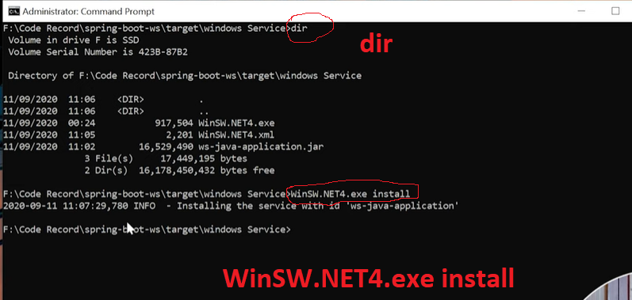

Steps 5. Goto start and open run

1. Type Service
2. Check your java.jar is running or not
3. If not running then start the service again.

Example

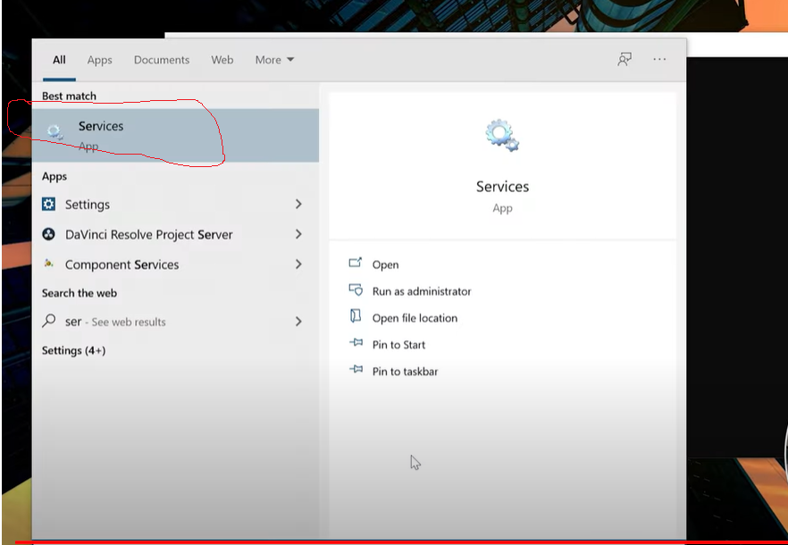

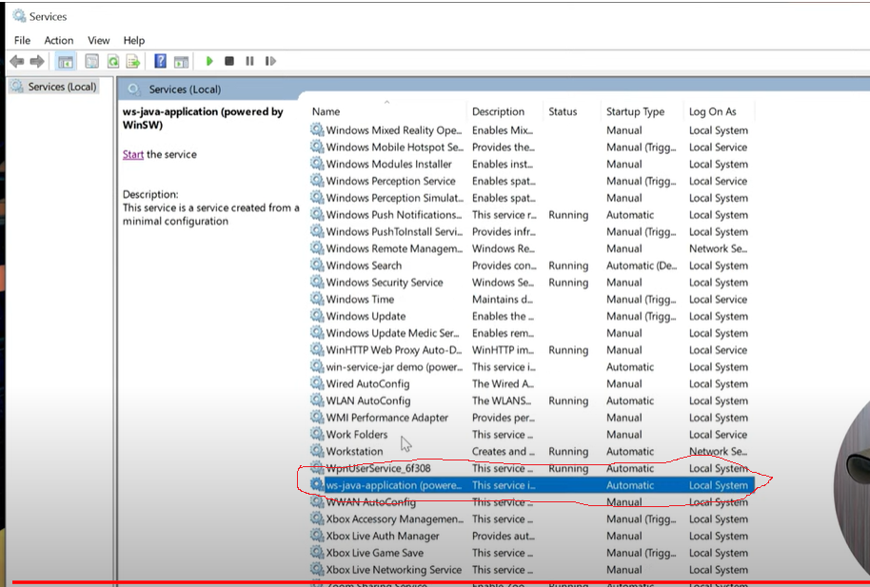

After that you service is working on local/remotely as your configuration

Example

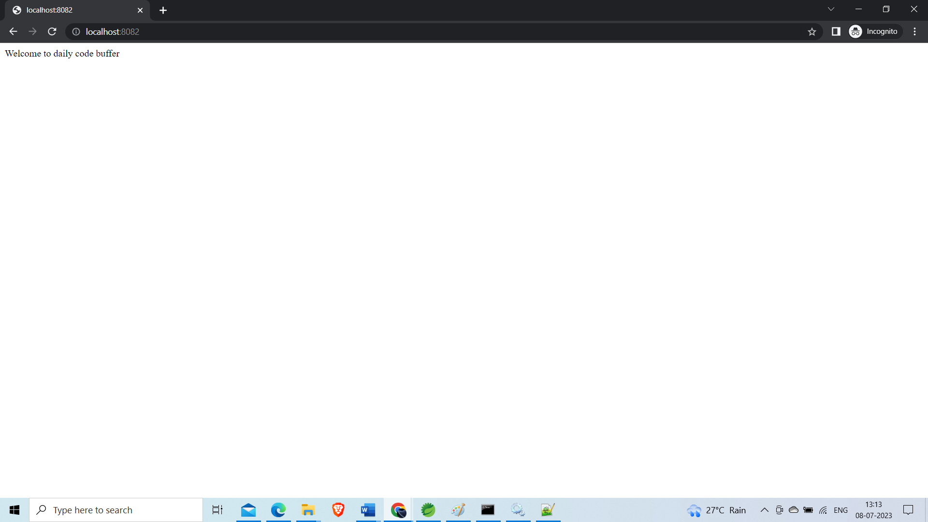

The End.

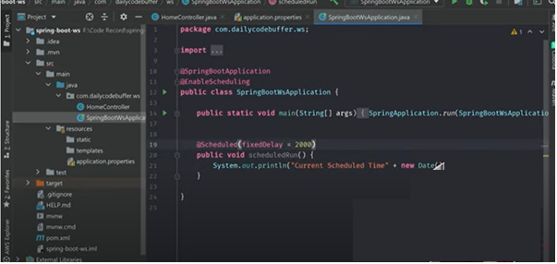

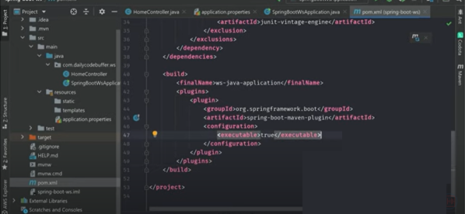

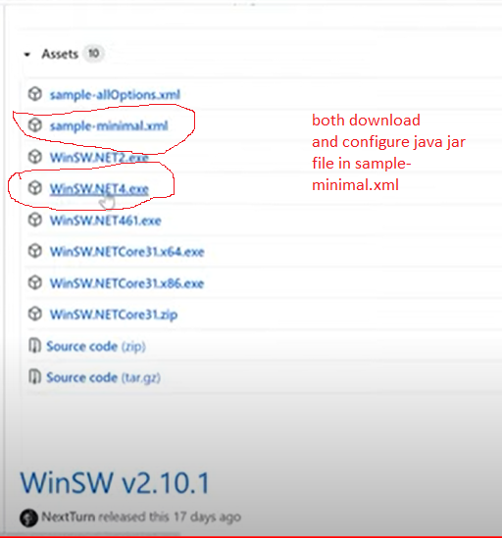

Your environment has been set up for using Node.js 18.16.0 (x64) and npm.

C:\Windows\System32>cd C:\Users\Lenovo\Documents\ProductionEnvirmental

C:\Users\Lenovo\Documents\ProductionEnvirmental>dir

Volume in drive C has no label.

Volume Serial Number is 44B2-04A5

Directory of C:\Users\Lenovo\Documents\ProductionEnvirmental

08-07-2023 12:30 <DIR> .

08-07-2023 12:30 <DIR> ..

08-07-2023 12:23 852,480 WinSW.NET4.exe

08-07-2023 12:29 2,263 WinSW.NET4.xml

08-07-2023 12:22 17,074,326 ws-java-application.jar

3 File(s) 17,929,069 bytes

2 Dir(s) 33,562,284,032 bytes free

C:\Users\Lenovo\Documents\ProductionEnvirmental>WinSw.Net4.exe install

2023-07-08 12:33:43,203 INFO - Installing service 'ws-java-appliction (powered by WinSW) (ws-java-application)'...

2023-07-08 12:33:43,240 INFO - Service 'ws-java-appliction (powered by WinSW) (ws-java-application)' was installed successfully.

C:\Users\Lenovo\Documents\ProductionEnvirmental>